CMP9135M Computer Vision – week 5 – Texture Analysis

**Pattern Recognition – Texture Analysis**

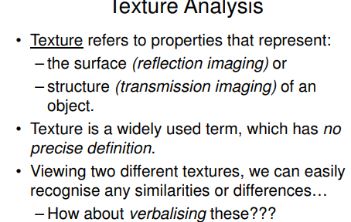

We might define Texture as “something consisting of mutually related elements”

We are considering a group of pixels (i.e. a texture primitive or texture element) and the texture described is highly dependent on the texture scale.

**Texture Examples**

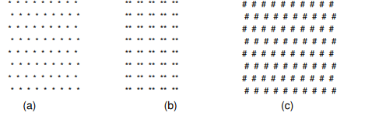

Figures A and C show that the same spatial primitives do not guarantee texture uniqueness. Spatial primitives (the fact that things are distributed the same way ) are NOT sufficient for texture description.

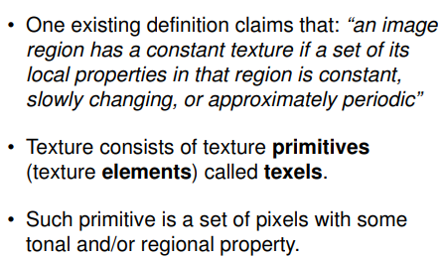

**Texture Analysis**

**Texture description** is based on tone and structure. Tone describes pixel intensity properties on the primitive, while structure reflects spatial relationships between primitives.

Texture description is scale dependent.